Above are two plots of GPS and Wifi data. Both plots are from running these sets of bags from beginning to end which is about 36 minutes of data: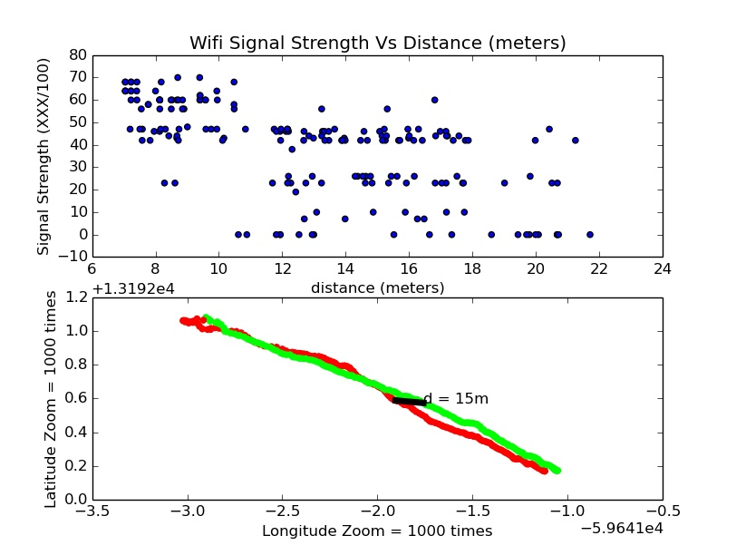

dn1_2015-01-16-12-48-41_1.bag

dn1_2015-01-16-12-31-47_0.bag

dn3_2015-01-16-12-37-25_2.bag

dn3_2015-01-16-12-55-56_3.bag

The top plot is the wifi signal strength vs the distance in meters. From this scatter plot we can see from around after 10m we start getting signal drop-off where the signal strength is zero. We also get a pretty big spread from 0 to 60 percent signal strength at this distance. We can also see that below 12m we normally stay at or above 40 percent signal strength. Unfortunately from these two sets of bags we do not have enough data to see when the signal strength drops off completely and at what distance we always get 100 percent signal strength (If there is such a distance that will give us 100 percent signal strength). The bottom plot is a map of the GPS coordinates with a line of distance for reference. These GPS coordinates correspond to the data in the top plot.

Below are some sub plots of the data above:

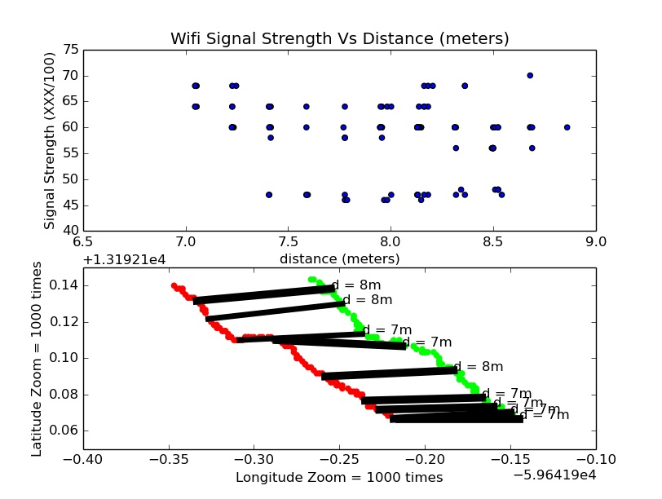

Above we can closely see that at around 7-8m our signal strength spread goes from around 45% to 70%. (The bars do change line width depending on the signal strength).

From th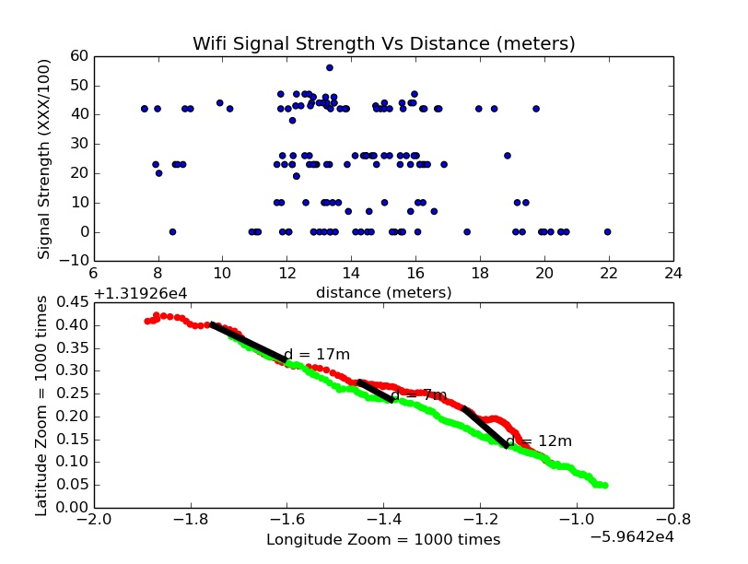e graph above we can see that after about 10m, we rarely get a signal strength above 50% and we frequently get signal drop-off.

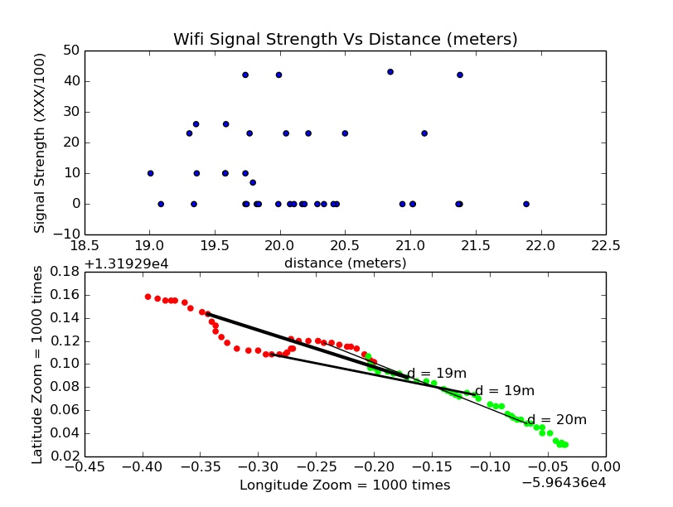

The graph above shows us that after about 19m we rarely get a signal strength above 30%.

Conclusion:

This data helps us see there is definitely a correlation between the distance between GPS coordinate distance and the Wifi signal strength. This is useful because we can use the signal strength as a rough means of calculating distance when GPS signal is unavailable.